ICT PROJECT DOCUMETATION

**Submitted To :**

**Laura Antochi**

**Submitted By : Team01**

**INDEX**

1. TEAM DESCRIPTION…………………………………………………………………...2
2. PROJECT DESCRIPTION………………………………………………………………..2
3. PROJECT AUDIT……………………………………………………………………………5
4. CLIENT AGREEMENT……………………………………………………………………7
5. PROJECT DEVELOPMENT…………………………………………………………….12
6. REFERENCES……………………………………………………………………………….24

**TEAM DESCRIPTION**

We Team 08 consists of four members, which includes

1. Chaithanya Krishna
2. Preetham Reddy Todima
3. Pruthvi Muniraj
4. Rohan Kunal Salla

We are developing a Mobile application for Universities Students. This is an application where we could analyse student’s ability to work in projects based on citizenship behaviour ,team work , leadership and work product .

**TEAM CONTRIBUTION**

|  |  |  |  |  |  |  |
| --- | --- | --- | --- | --- | --- | --- |
| **Team Member** | Planning | Documentation | Design | Research | Client Agreement | Prototype |
| **Chaithanaya Krishan** |  |  |  |  |  |  |
| **Preetham Reddy** |  |  |  |  |  |  |
| **Pruthvi Muniraj** |  |  |  |  |  |  |
| **Rohan Kunal Salla** |  |  |  |  |  |  |

**PROJECT DESCRIPTION**

**PROJECT JUSTIFICATION:**

The main intension to design this application is to estimate student’s ability towards working on a project based on certain criteria. Depending upon Citizen behaviour, user rate’s a mate on how promptly he arrives to group meetings , attends group meetings, completes his given work on time, if he is thoroughly prepared for group meetings and notifies in advance of late meetings .

Considering teamwork as criteria, user rate’s a mate on his behaviour in group discussion or how good he participates in group discussions , how creative he is while he offers an idea or suggest ideas, ready to criticism or answer questions , acknowledges expertise of others , to ensure he does not dominate group discussions, if he is willing to give and take suggestions , listens attentively to others and follows through deliverables.

Leadership, as most important criteria, the user rate’s a mate from Solicits divergent opinions which is estimated by others, shares his leadership goals with other members, suggests important issues for discussions, how good he keeps his discussion focused on key issues raised by clients, helps others when own work is finished and pulls a project together at the end.

Depending on the student’s Work product, the user can rate a mate on how good he can explain own work to others, corrects his own problems, how good he conducts research as needed to the project. The Student should be able to write in agreed upon style, check if submitted work Is complete, written work is professional, oral presentations is well rehearsed and output consistent with expectations

Considering average rating of all the criteria above the solution is gained by rating a student from the scale 0-5.

Depending on average scores the user decides if he wants to work or consider the student for the project followed by giving additional comments.

**PROJECT GOALS**

* The most important goal is to design and develop a mobile application for University Students.
* Provide Confidentiality for all the content and user profiles in the application.
* Design and develop functionalities according to the client requirement.
* Design better user interface with maximum effectiveness by avoiding unnecessary and unwanted options.
* To develop a highly efficient mobile app with minimum complexity in operation and quick and easier functionalities.

**PROJECT TIMELINE**

|  |  |  |  |
| --- | --- | --- | --- |
| **RELEASE VERSION** | **NO** | **FEATURES** | **DATE OF RELEASE** |
| **Alpha  5 weeks** | 1 | Profile | 25/05/2018 |
| 2 | Login |
| 3 | Change of details |
| 4 | Find a mate |
|  | 5 | Rate a mate |  |
|  | 6 | My rating |  |
| **Beta  5 weeks** | 1 | Monitoring/Admin |  |
| 2 | Notify admin |
| 3 | Reply to rating |
| 4 | Notify new password |
| 5 | Notify user |
| **Final  5 weeks** | 1 | Message |  |
| 2 | Analytics |
| 3 | Security |
| 4 | Bug fixes |
|  |  |  |  |

The above table shows the project timeline on the basis of three milestones and the release of three versions of the application as expected. It is expected to complete the project by the mid of June 2018 and the proposed has been agreed by the client we as a team is confident enough that we can achieve the proposed milestone on time. Also, we a team of four are not being over optimistic about the time limits as we all know our limitations and the skills which we have, so we are already in track with the learning process and to deliver the best of us.

Also, we estimated the days for each user stories according to its difficulties and plenty of time has been allocated to various user stories as a proper testing will also be conducted. So, it is clear that we will be able to complete the project according to the plan.

**PROJECT AUDIT**

AVAILABLE DAYS: 5 X 4 = 20(TEAM)

TOTAL ESTIMATED DAYS: 40 (PROJECT)

INDIVIDUAL AVAILABILITY: 10 DAYS (2 DAY/WEEK)

TOTAL NO OF WEEKS: 5

**MILESTONE 1: ALPHA RELEASE**

Alpha release is the first stage in the release of the mobile application and only the features which are mentioned below will be delivered in the estimated time.

USER STORIES: ALPHA

|  |  |  |  |
| --- | --- | --- | --- |
| **TITLE** | **DESCRIPTION** | **CLIENT PRIORITY** | **TIME ESTIMATE (DAYS)** |
| Login | User logins with his jc number and pre-defined password | 10 | 5 |
| Details change | Validate his student Id , email and password . | 10 | 5 |
| Find  a mate | User finds his mate by student id or number | 20 | 5 |
| Rate  a mate | User rates from 0-5/ NA | 20 | 5 |

The development for the Alpha release will start from the first week of January 2018 and it is expected to release on 02/02/2018.

Total of 20 days has been allocated for the Alpha development process and each one of the group member will spending one day per week for that 5 weeks. Which in turn will contribute to a total of 20 days.

**MILESTONE 2: BETA RELEASE**

Beta is the second stage in the development stage and it is estimated to complete and release the beta version on 13/04/2018. The time limit spared for the development of Beta version is also 5 weeks.

USER STORIES: BETA

|  |  |  |  |
| --- | --- | --- | --- |
| **TITLE** | **DESCRIPTION** | **CLIENT PRIORITY** | **TIME ESTIMATE (DAYS)** |
| My rating | User is able to see his own ratings. | 30 | 5 |
| Notify  new password | User receives an email to setup a new password | 30 | 5 |
| Reply  to rating | User can reply to the ratings received | 40 | 5 |
| Admin Monitoring | Admin can see all the ratings and monitor them | 50 | 5 |

Each team member will spend the same amount of time as in Alpha release and Beta version is also estimated to take 20 days.

**MILESTONE 3: FINAL RELEASE**

Milestone 3 is the final stage of the project and a fully functional mobile application is estimated to deliver at the end of this stage to the client. Final stage of development is also estimated to have 20 days and each team member will spend one day per week for 5 weeks.

USER STORIES: FINAL

|  |  |  |  |
| --- | --- | --- | --- |
| **TITLE** | **DESCRIPTION** | **CLIENT PRIORITY** | **TIME ESTIMATE (DAYS)** |
| Testing | Sharing link of the app for testing by jcub students | 20 | 5 |
| Analytics | Show app usage to admin. | 20 | 5 |
| Bug fixes | Security measures and fixing problems | 30 | 10 |

**CLIENT AGREEMENT**

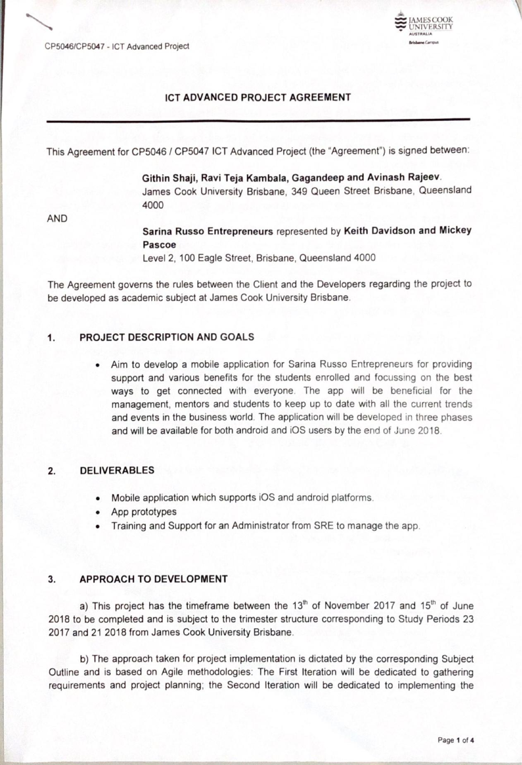

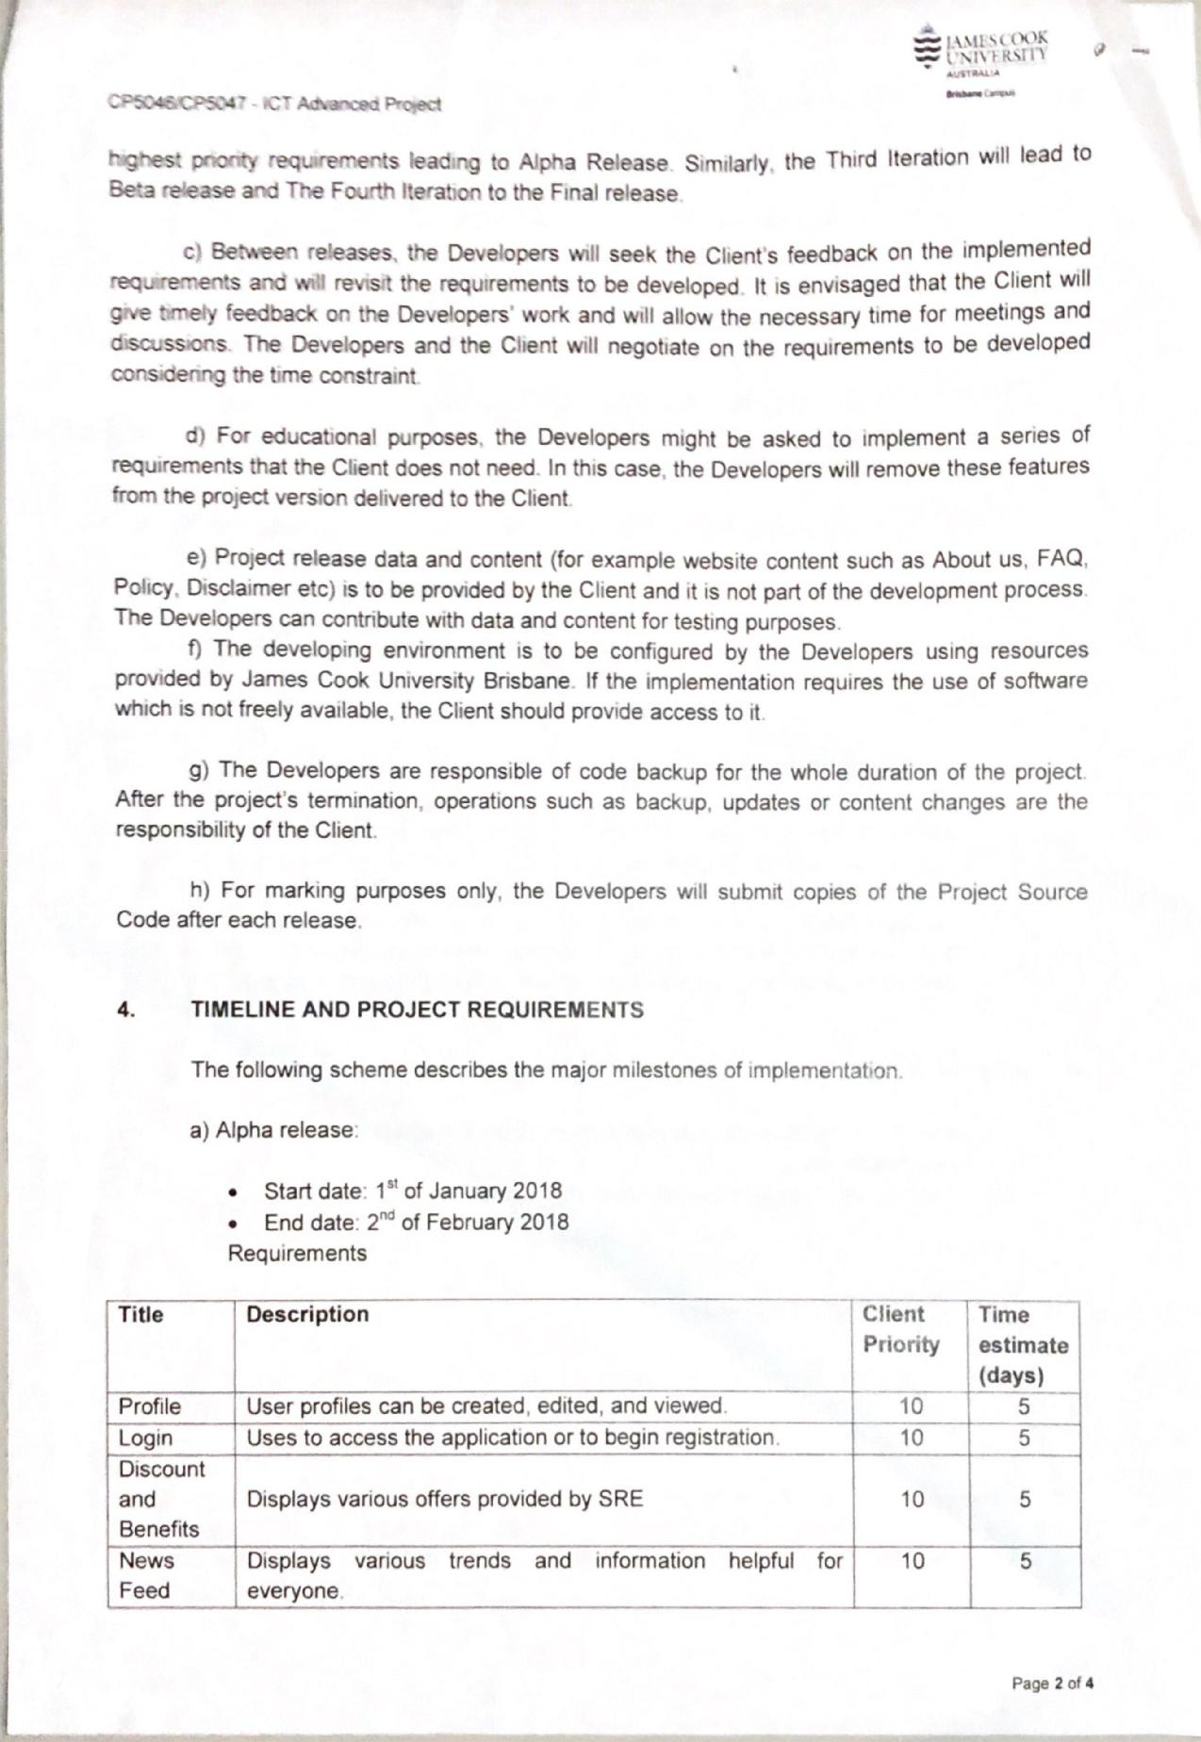

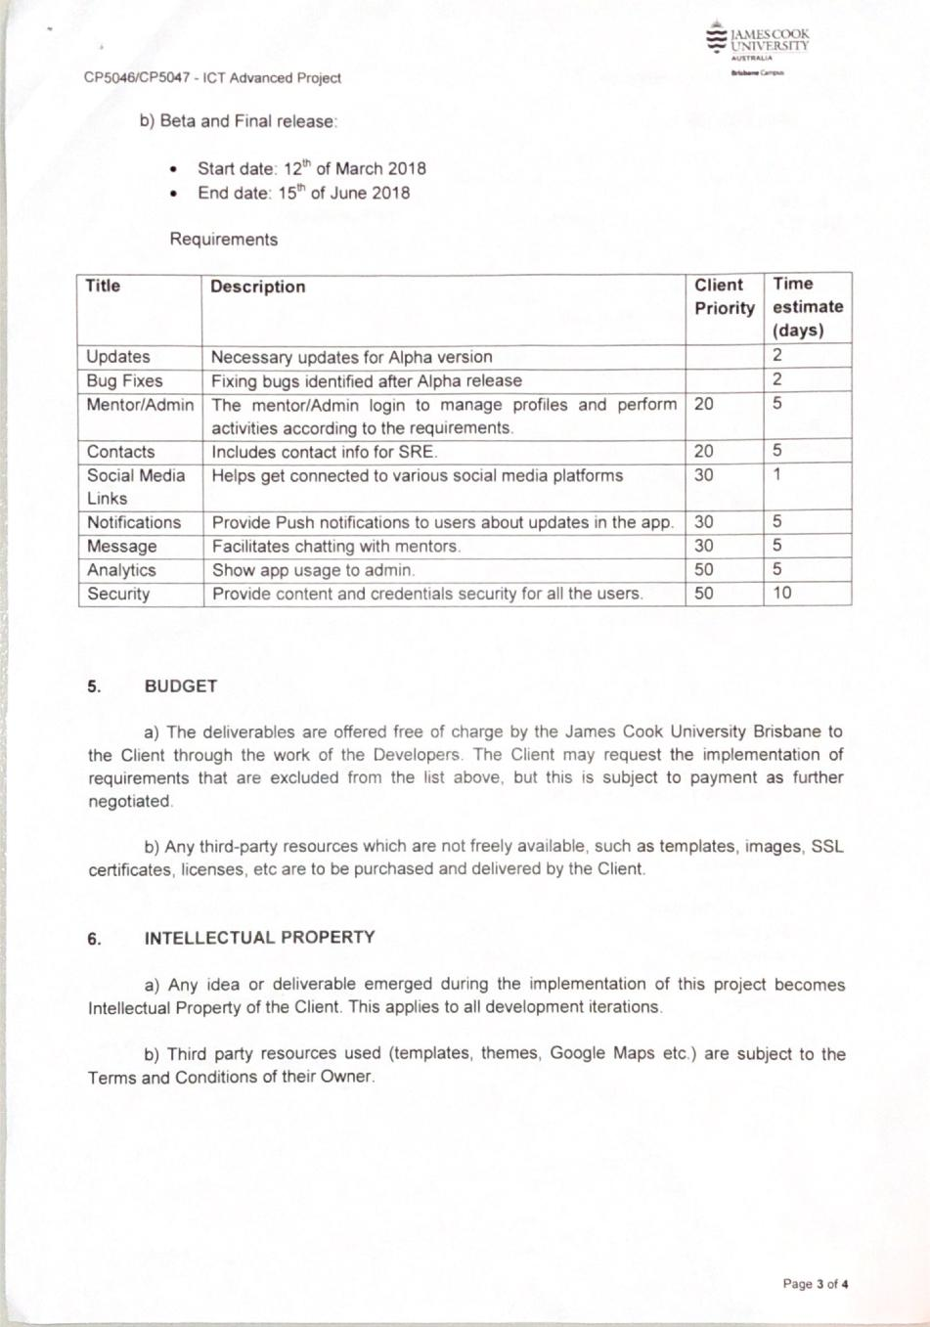

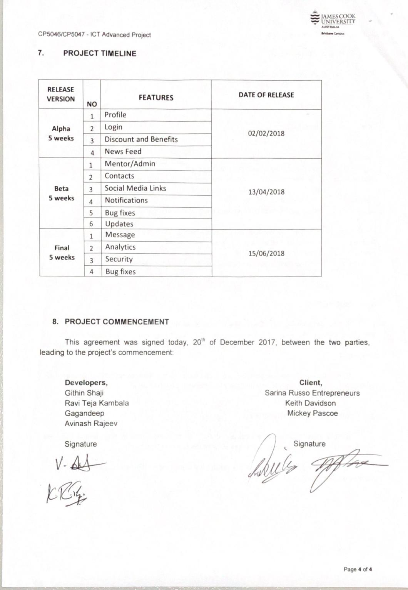

**PROJECT DEVELOPMENT**

**VERSION CONTROL**: Version control or the configuration management is an important tool in software development as multiple people are working on same project.

GitHub is a web-based hosting service for version control using git.It offers all of the distributed version control and source code management functionality of Git as well as adding its own features.GitHub is the configuration management tool used for developing Rate A mate application.

Link: https://github.com/todima/Rate-A-Mate

**PROJECT TOOLS**: Android Studio is used for the development and JavaScript will be the programming language which is used because of the cross-platform development.

SQL lite and PHP will be used for the back end and for server-side scripting.

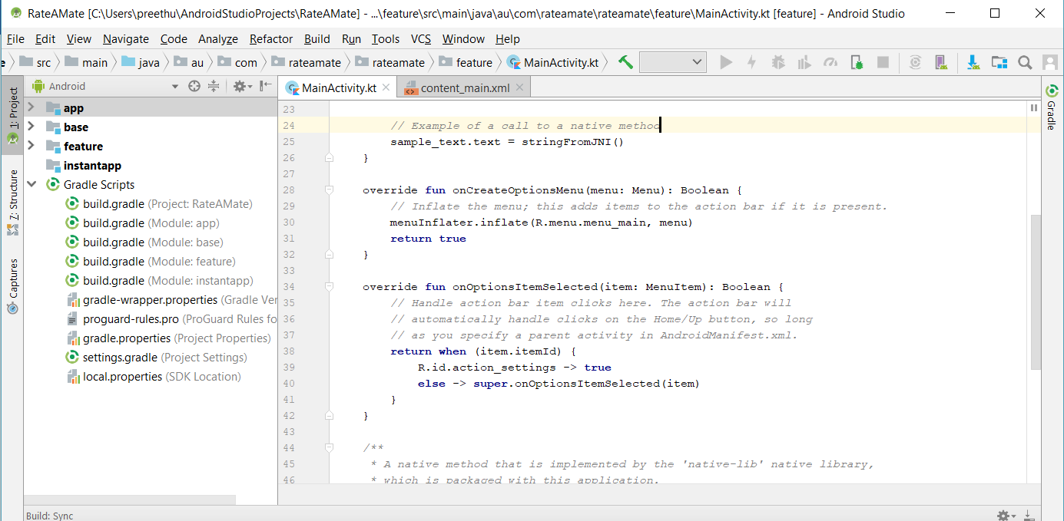

To setup a development environment for a developer in our team first Install Android Studio and then install cordova sdk for developing features in the app .

**TESTING TOOLS**: Testing will be carried out after the development in each stage in real time and various online tools are also available.

TestComplete Mobile is the testing tool which we are planned to test the application.

Also, the test will be conducted with the help of client and with different university students to collect the feedback at different stages of the development.

**SLACK CHANNEL:** Slack tool is used to communicate and manage the work within the team for the project.

Link: https://team01sre.slack.com/home

**PROTOTYPES**

Below are the different prototypes designed for the Mobile application.

Tool Used: **Balsamiq Mockups** is used to design the prototypes for mobile application.

**DESCRIPTION OF ICONS**

News Feeds

Messages

Discounts and Benefits

Social Media Links

Profile

Back

Notifications

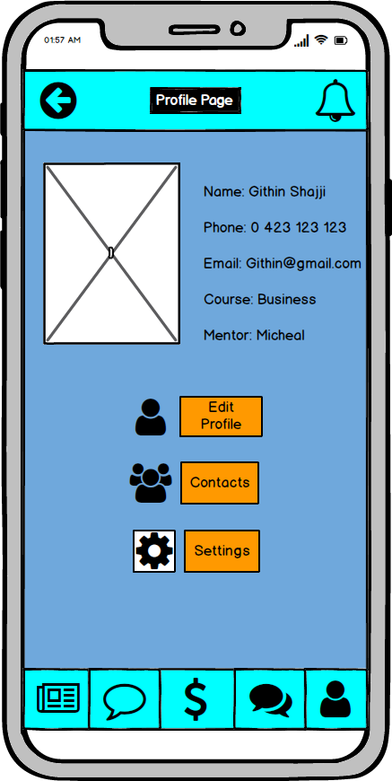

**Profile Page**

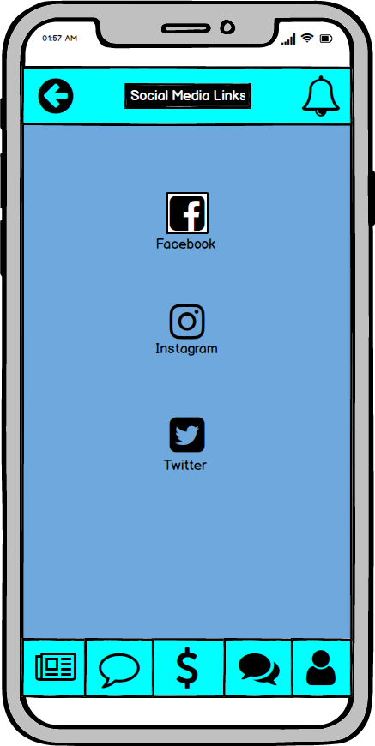

**Social Media Links**

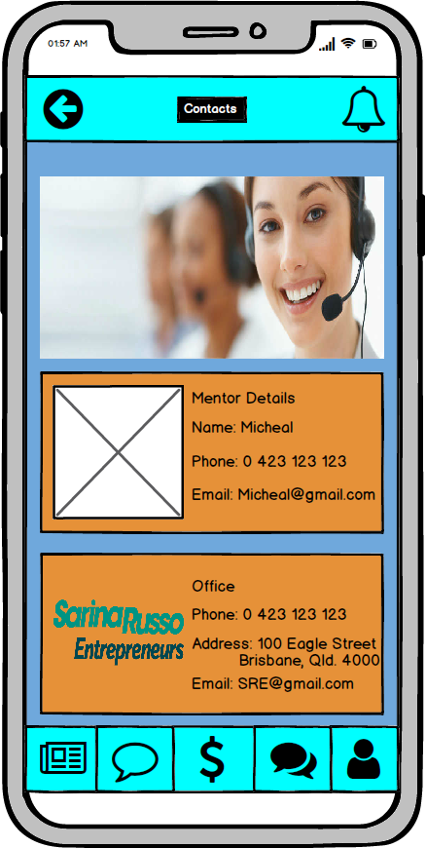

**Contacts**



**Discounts and Benefits**

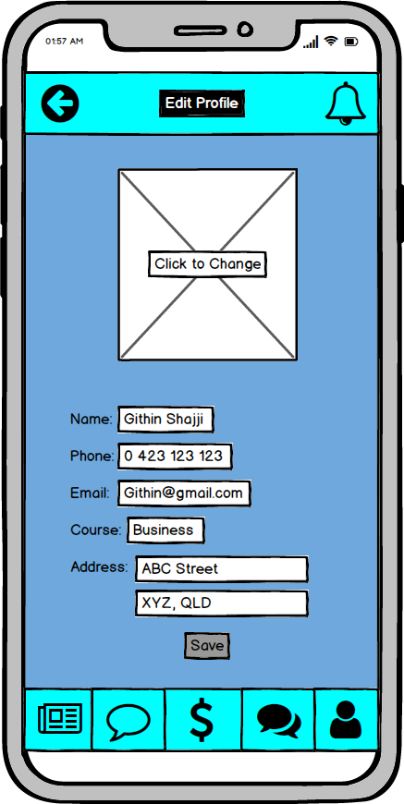

**Edit Profile**

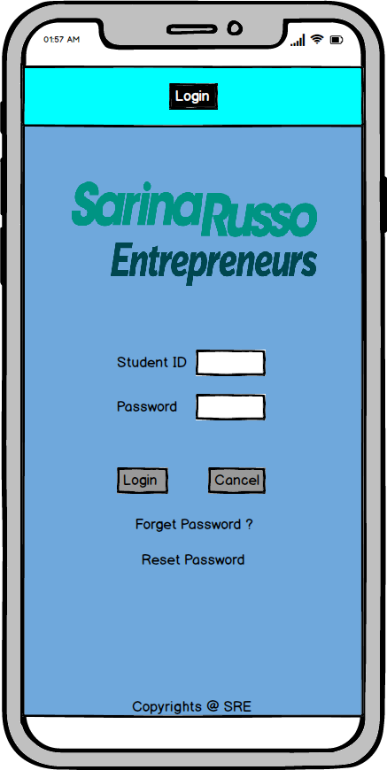

**Login**

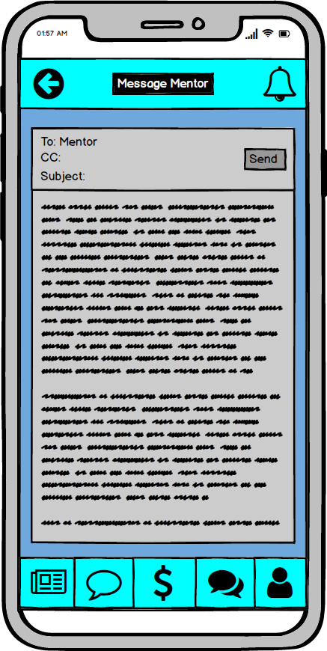

**Message Mentor**

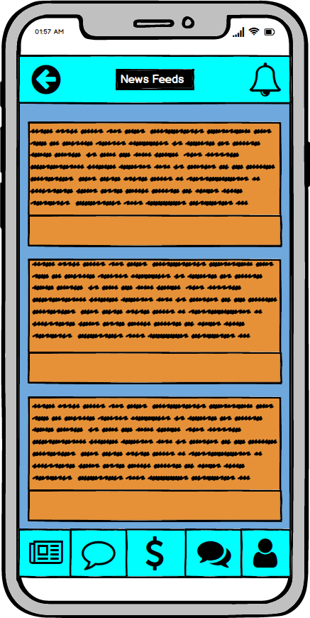

**News Feed**

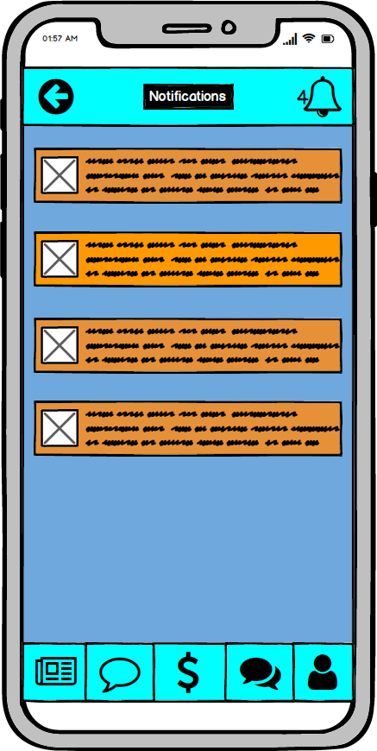

**Notification in App**

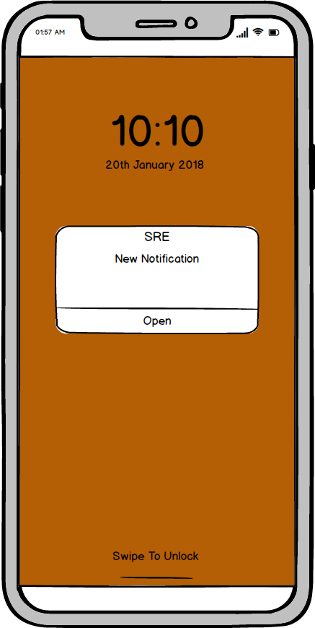

**Notification on Lock Screen**

**REFERENCES**

* <http://business.sarinarusso.com>
* <https://www.employment.gov.au>
* <https://smartbear.com/product/testcomplete/mobile-testing/>
* <https://ionicframework.com/>